ML Report

**Labeled Faces in the Wild (LFW):**

More than 13,000 facial photos gathered from the internet are included in the data collection. Names of the people depicted have been written on each face. 1680 of the individuals depicted had two or more different images contained in the data set.

The original database includes three different kinds of "aligned" photos in addition to four different sets of LFW images. In comparison to other image types, deep-funneled photos, according to the researchers, give better outcomes for most face verification algorithms. So, this dataset is the deep-funneled version that was posted.

Details about the image:

* Each image is available as "lfw/name/namexxxx.jpg," with the preceding zeros padding "XXXX" to four characters. The 10th George W. Bush image, for instance, can be found at "lfw/George W. Bush/George W. Bush0010.jpg."
* Each image is a 250x250 jpg that has been detected and the Viola-Jones face detector implemented using OpenCV. The cropping zone the detector returned was then automatically scaled to a consistent size and increased by a factor of 2.2 in each dimension to capture more of the head.

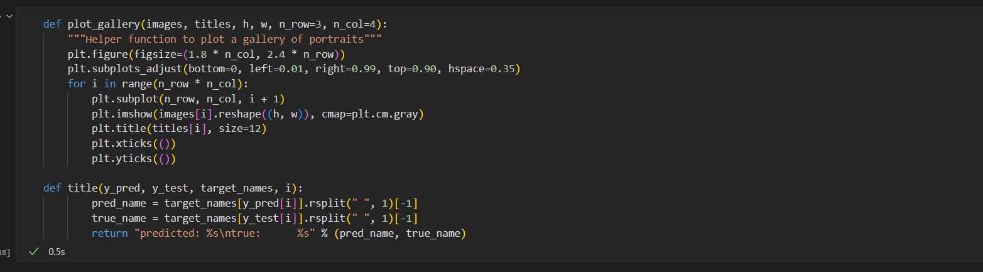

We are plotting eigen faces in the form of gallery

**PCA(Principal Component Analysis):** It is a technique for reducing the dimensionality of datasets, increasing interpretability but at the same time minimizing information loss. PCA is kind of a natural idea to use when looking at a dataset like this because the facial images have a relatively small number of degrees of freedom and we illustrated that graphically and were able to transform the image to a lower dimensional representation.

plot the result of the prediction on a portion of the test set

plot the gallery of the most significant eigenfaces

Face recognition problem would be much more effectively solved by training convolutional neural networks but this family of models is outside of the scope of the sci-kit-learn library. Interested readers should instead try to use PyTorch or TensorFlow to implement such models

The classification for 50 components: accuracy is 84%

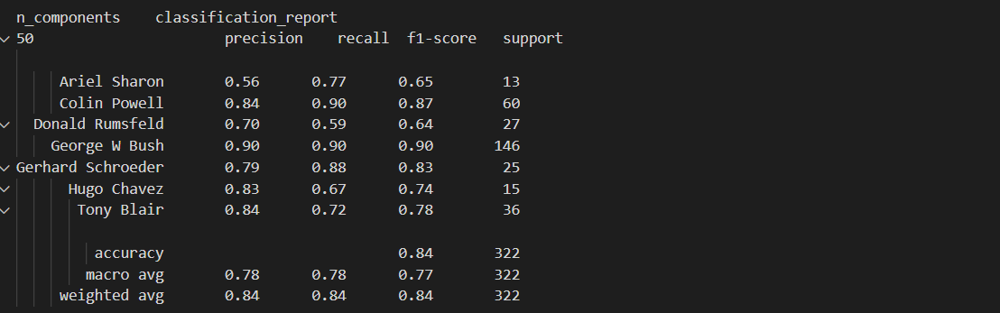

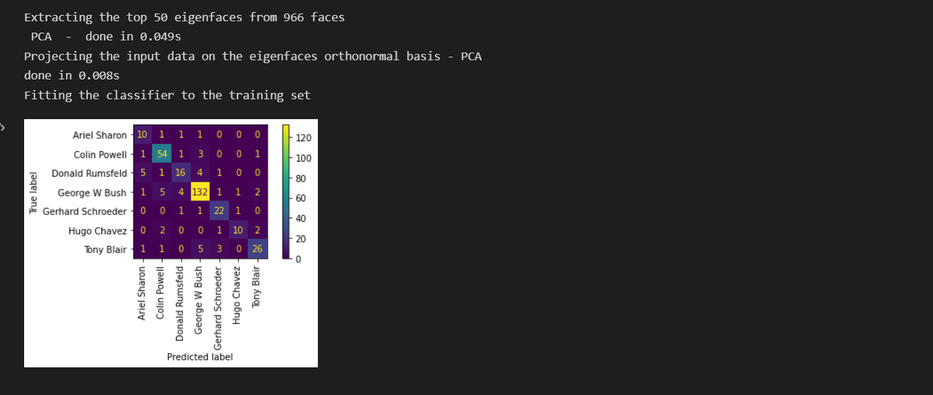

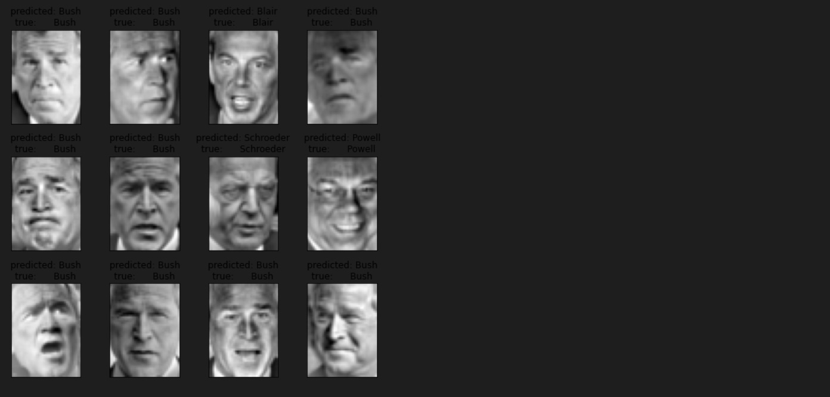

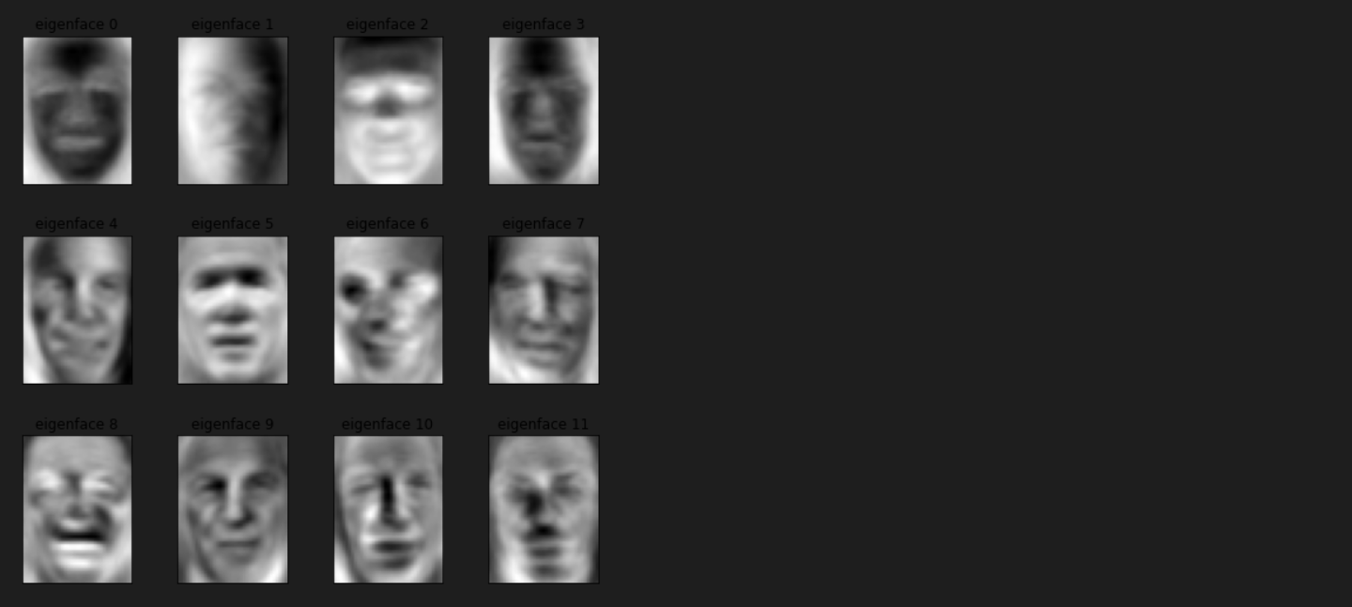

Classification for 75 components :accuracy is 88%

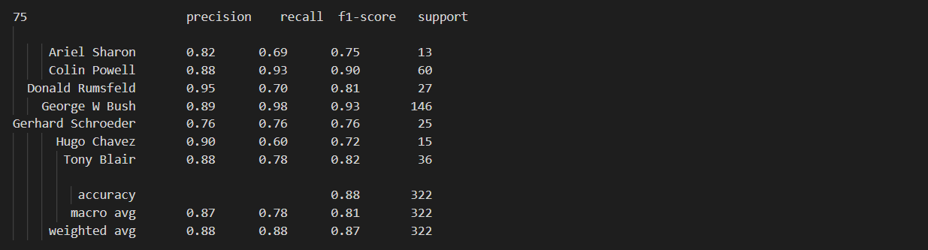

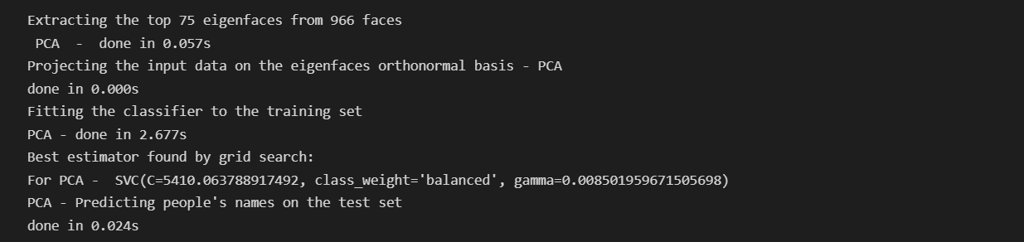

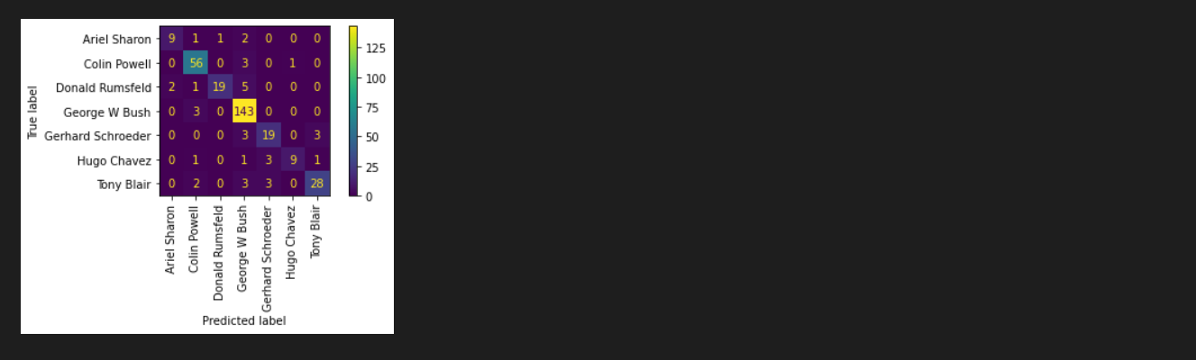

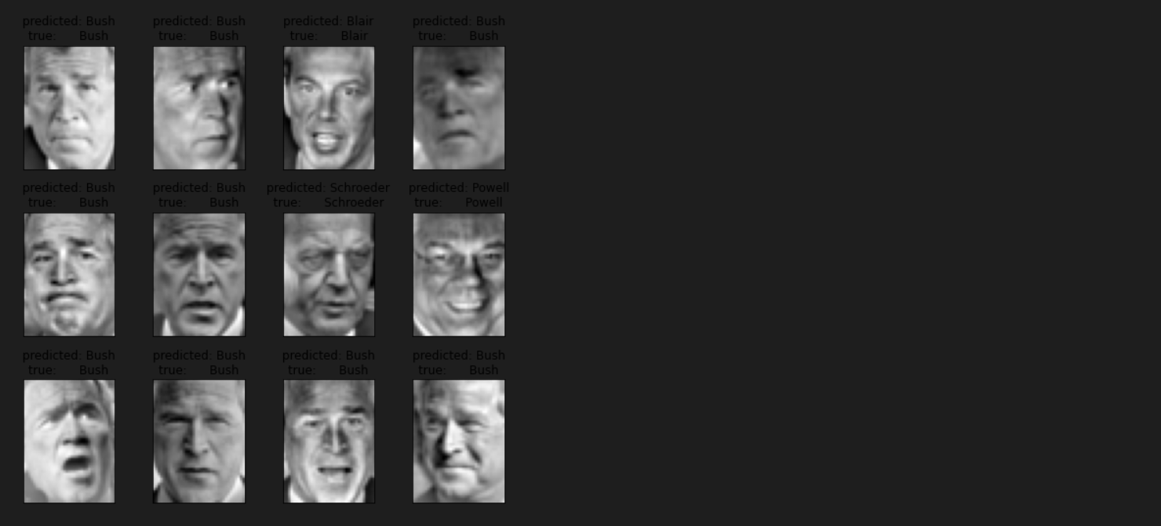

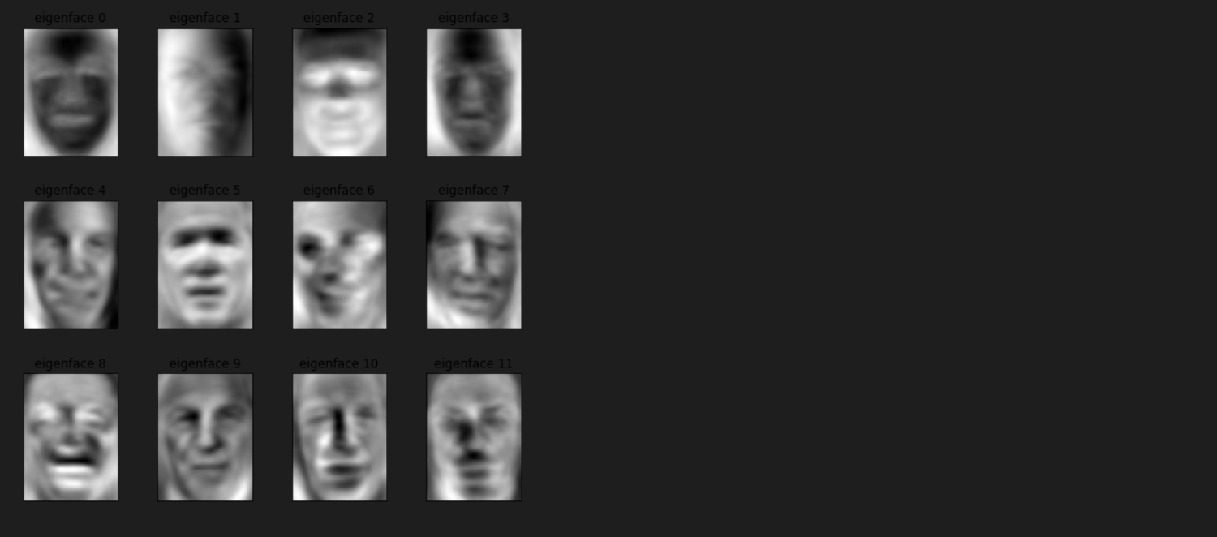

Classification for 100 components: accuracy is 85%

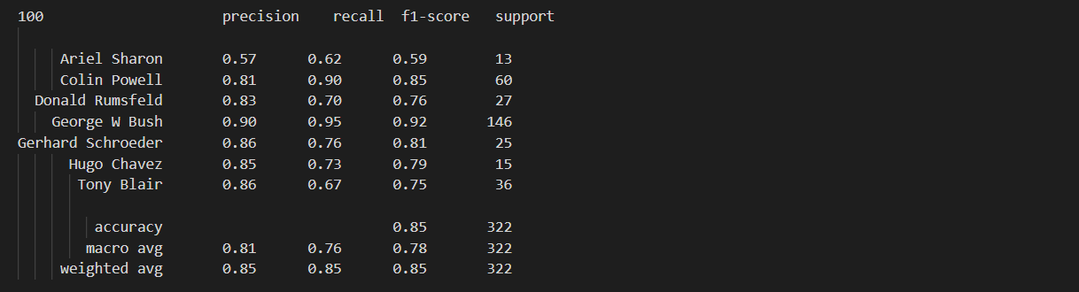

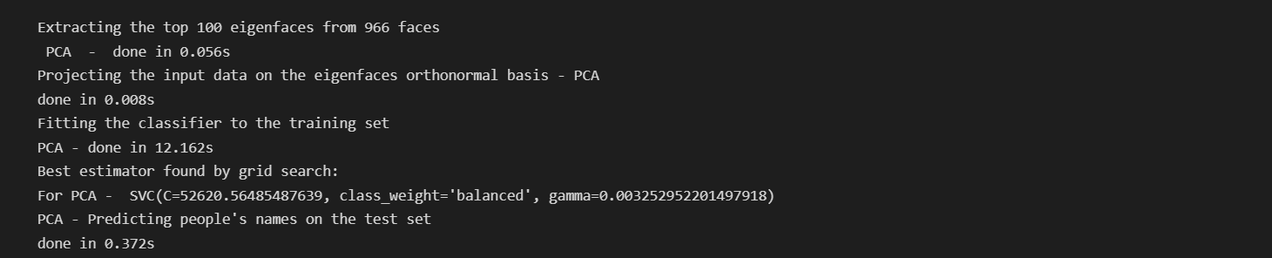

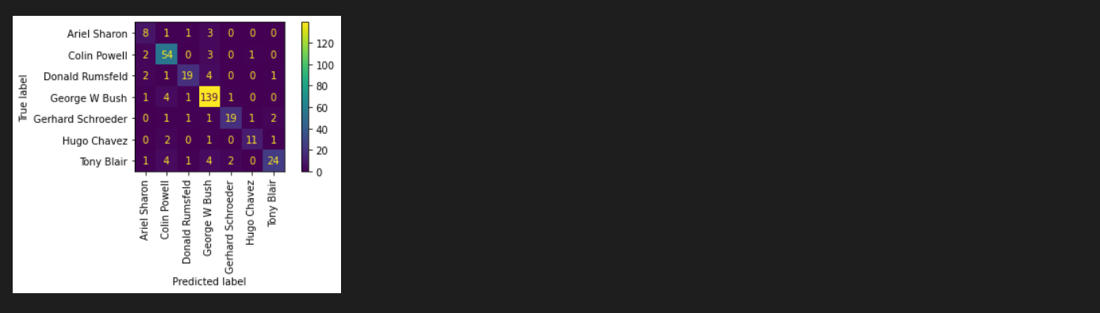

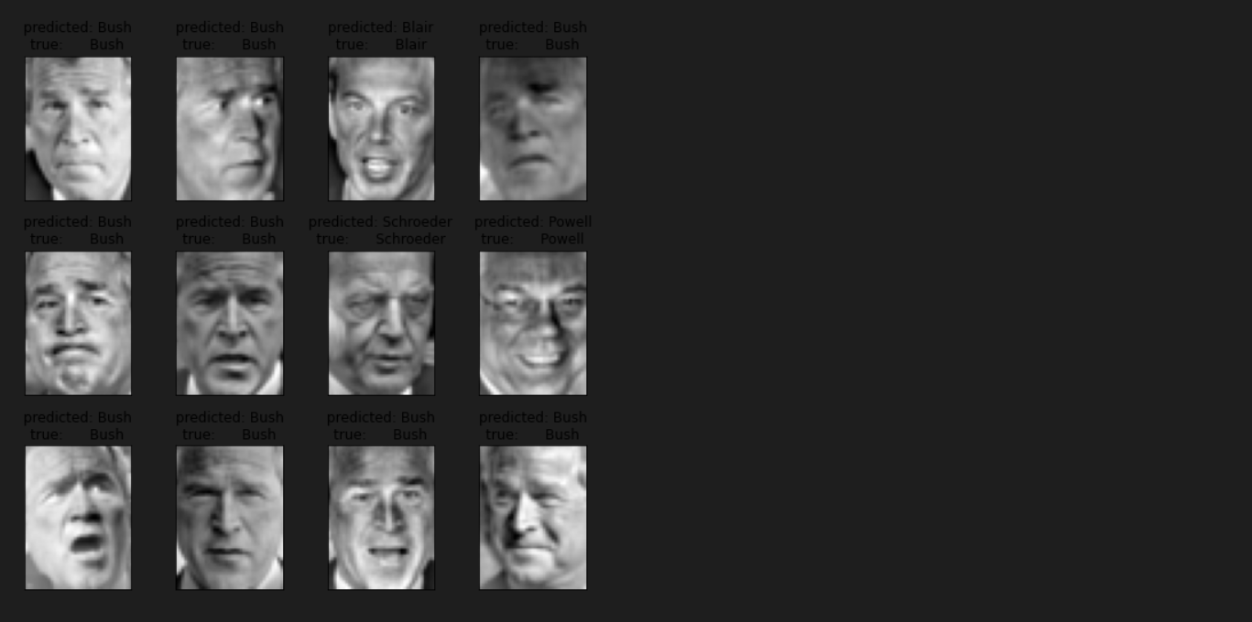

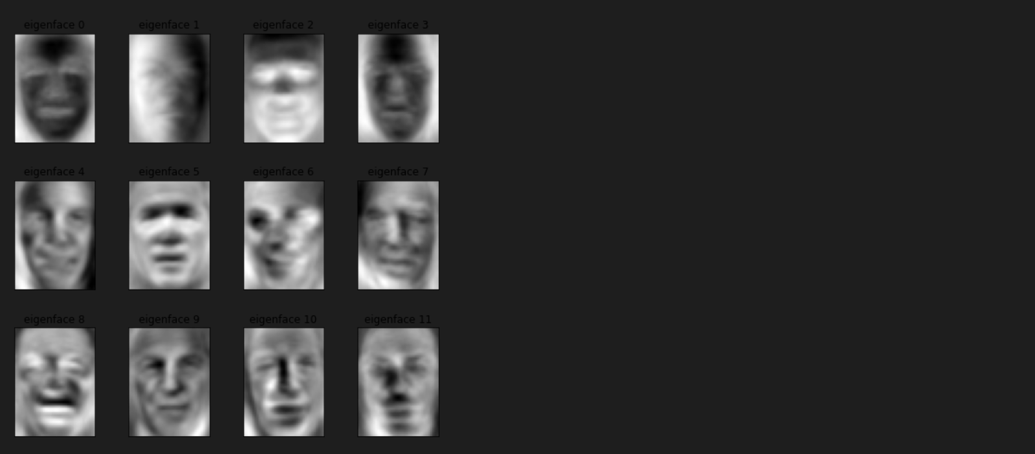

Classification for 150 components: accuracy is 85%

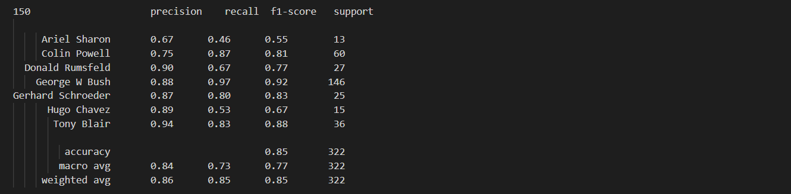

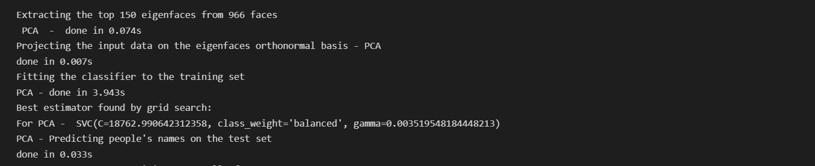

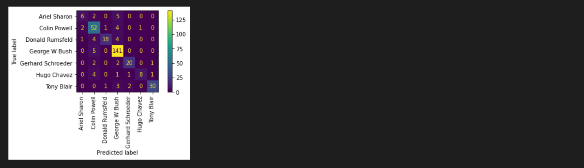

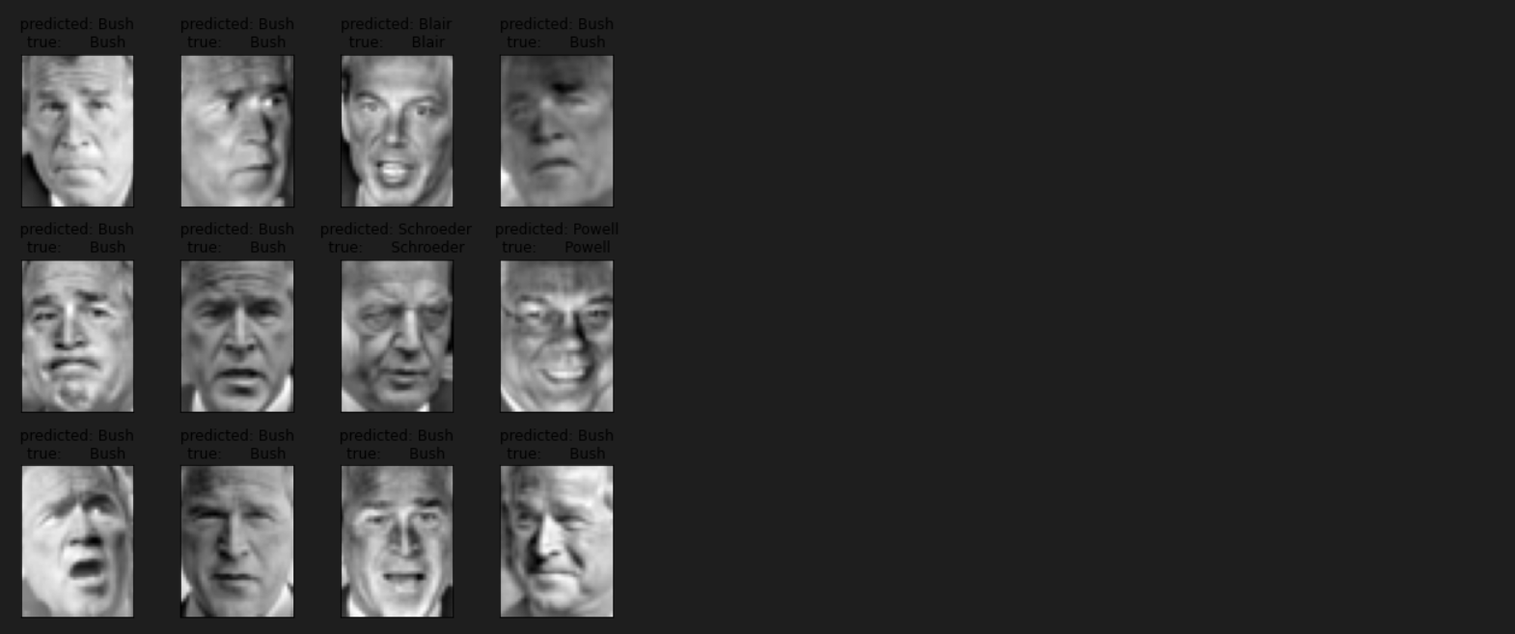

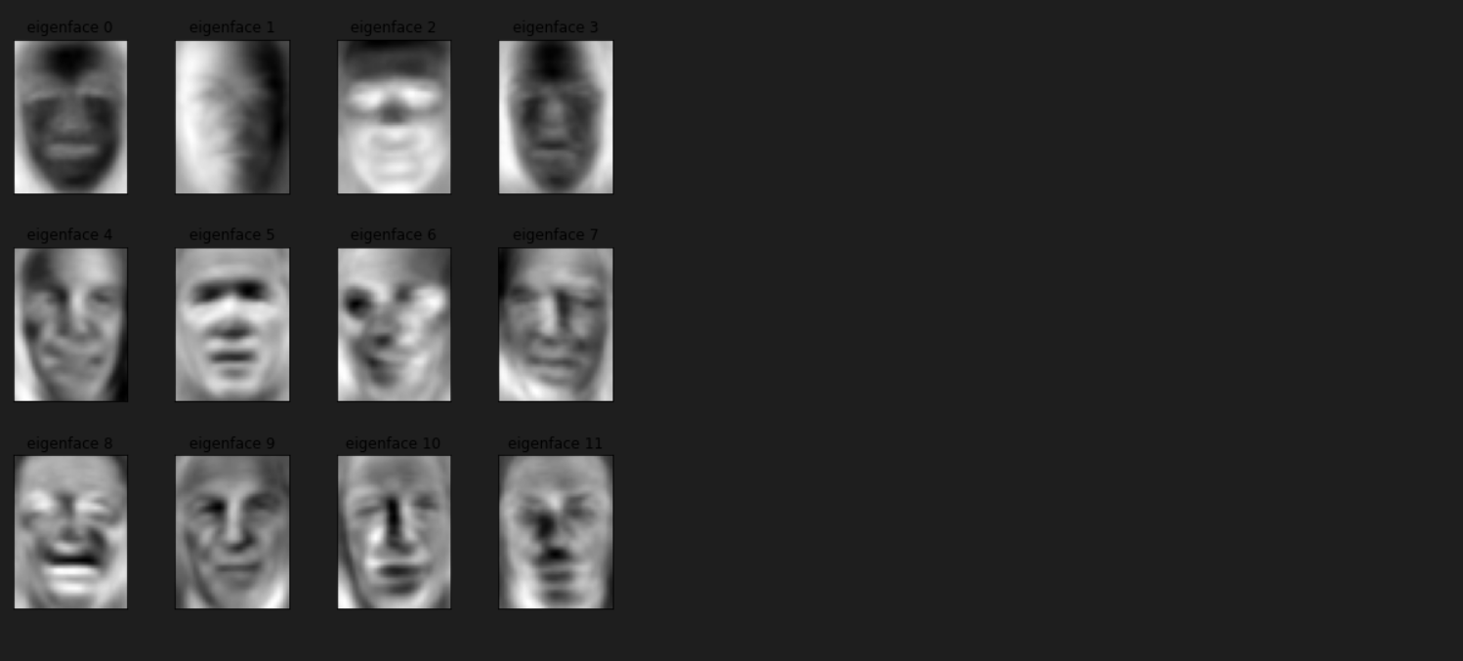

Classification for 200 components: accuracy is 85%

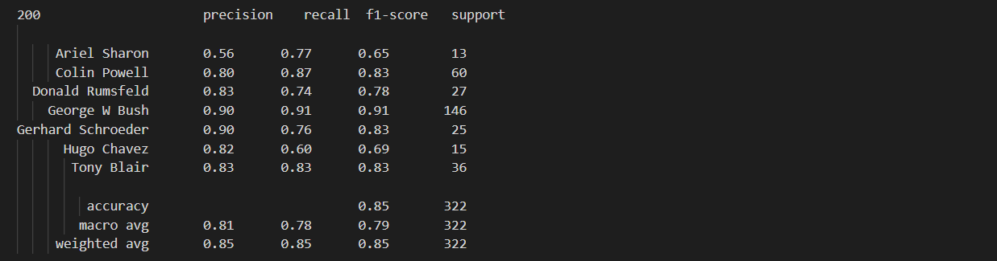

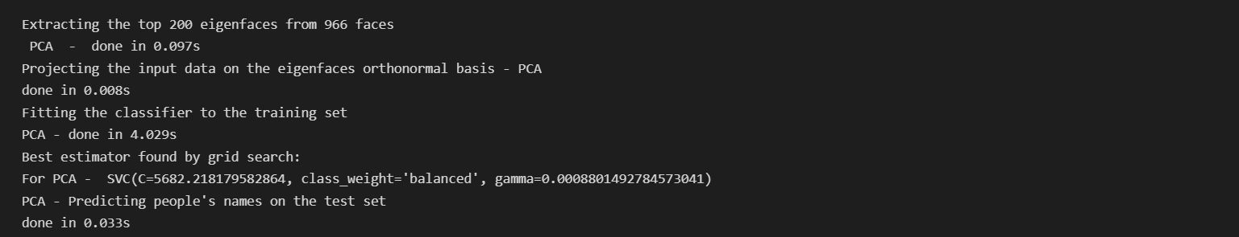

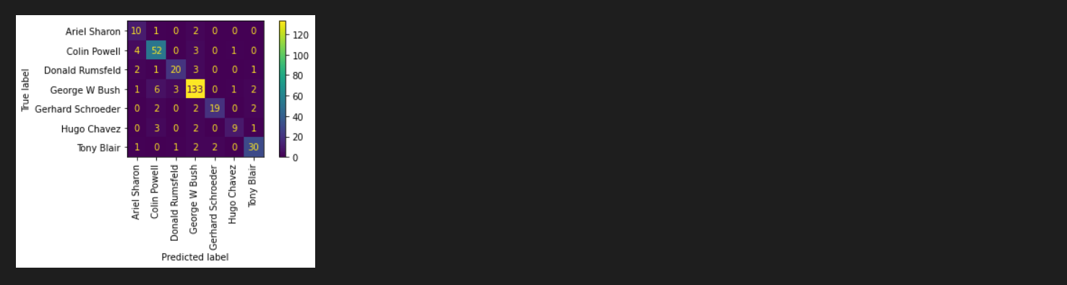

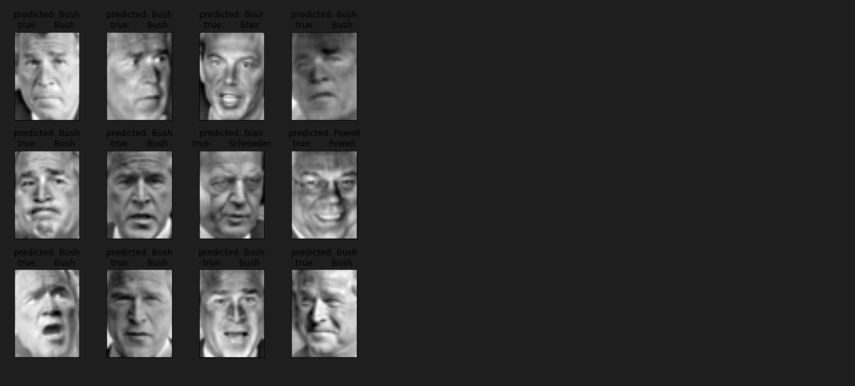

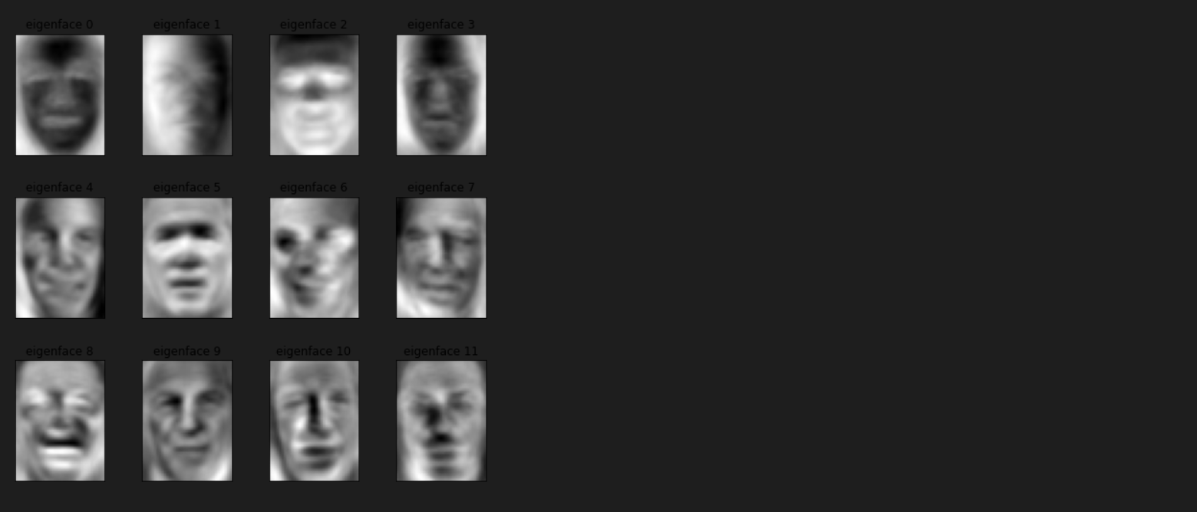

Classification for 300 components: accuracy is 80%

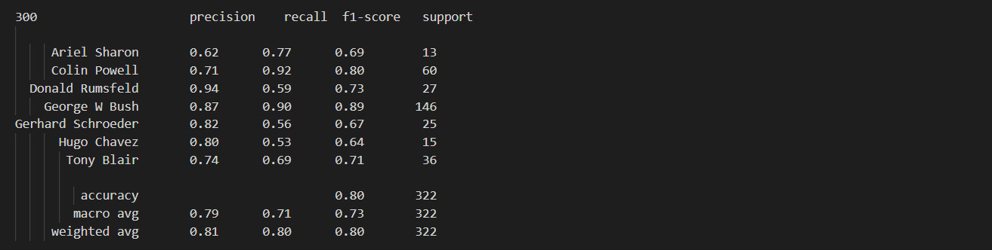

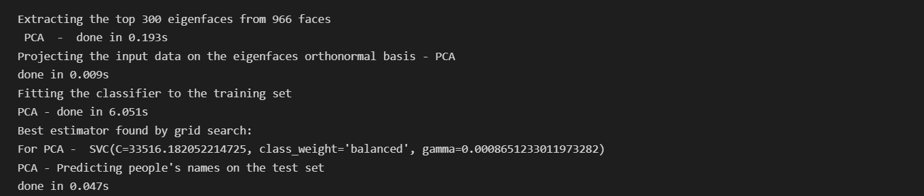

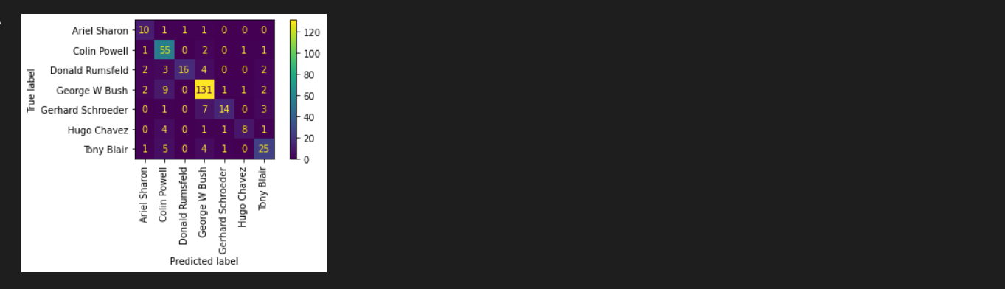

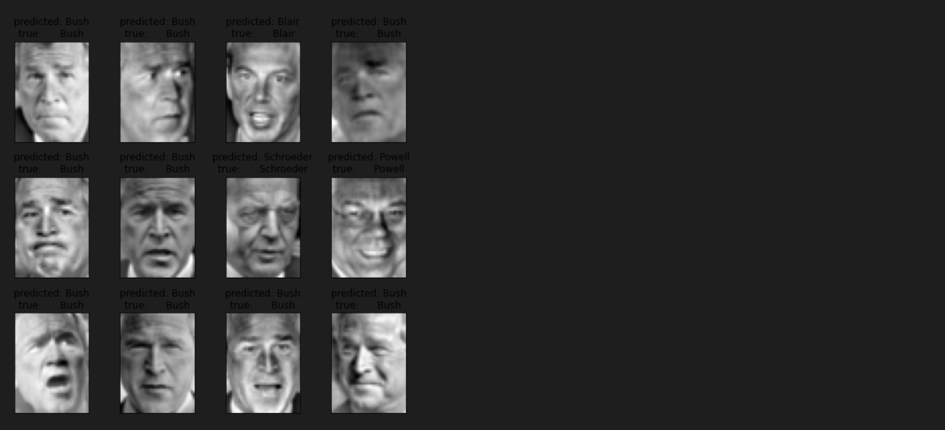

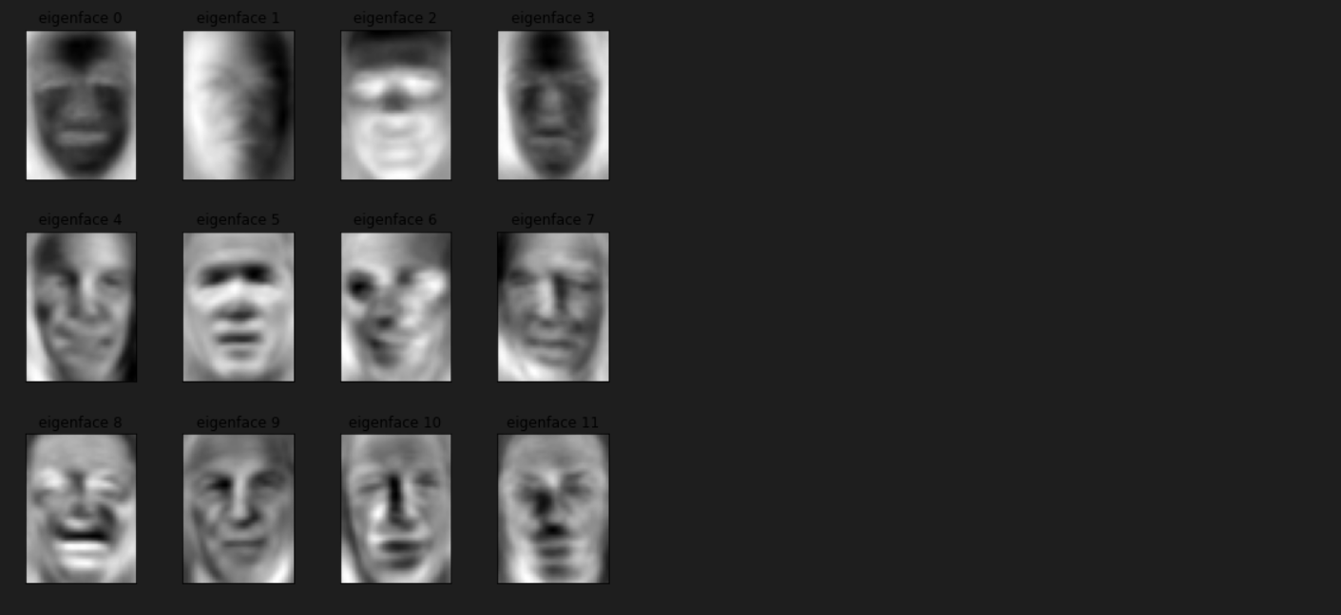

Classification for 500 components: accuracy is 73%

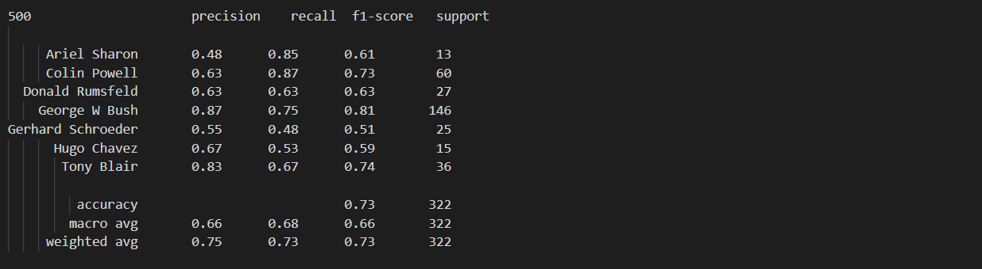

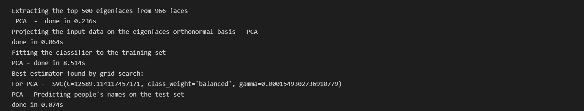

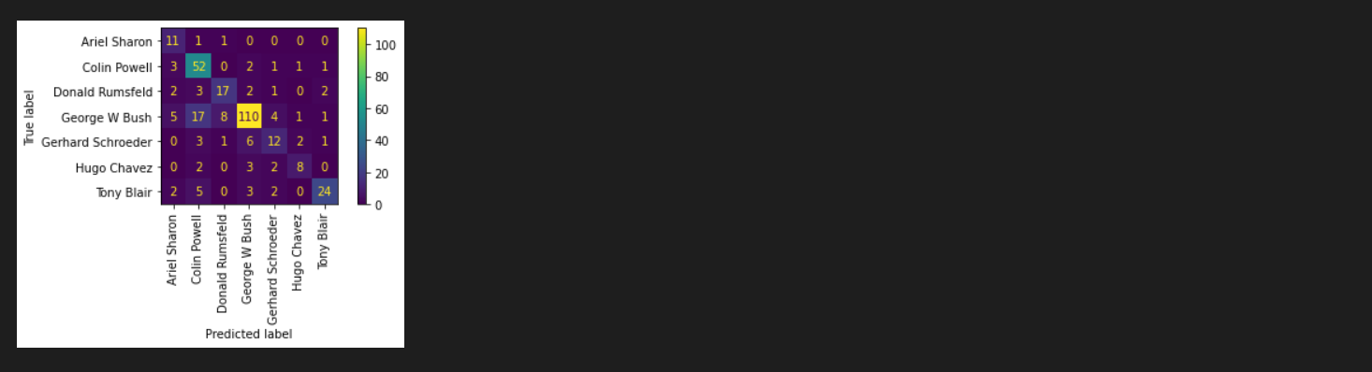

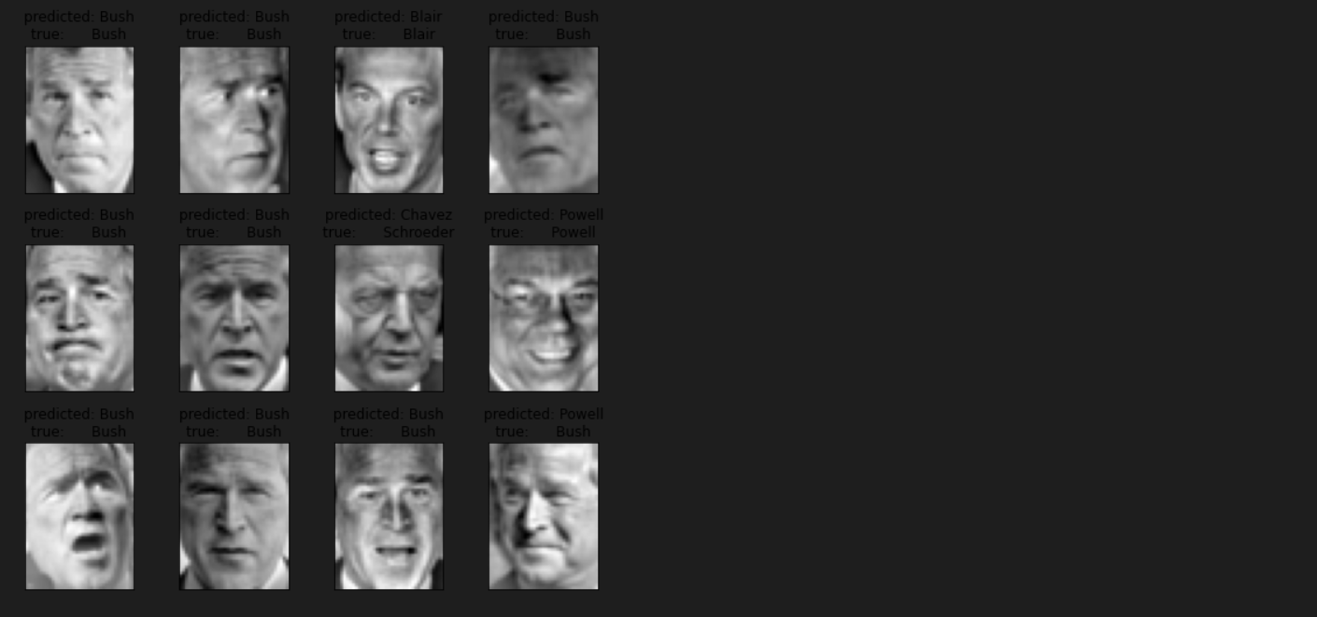

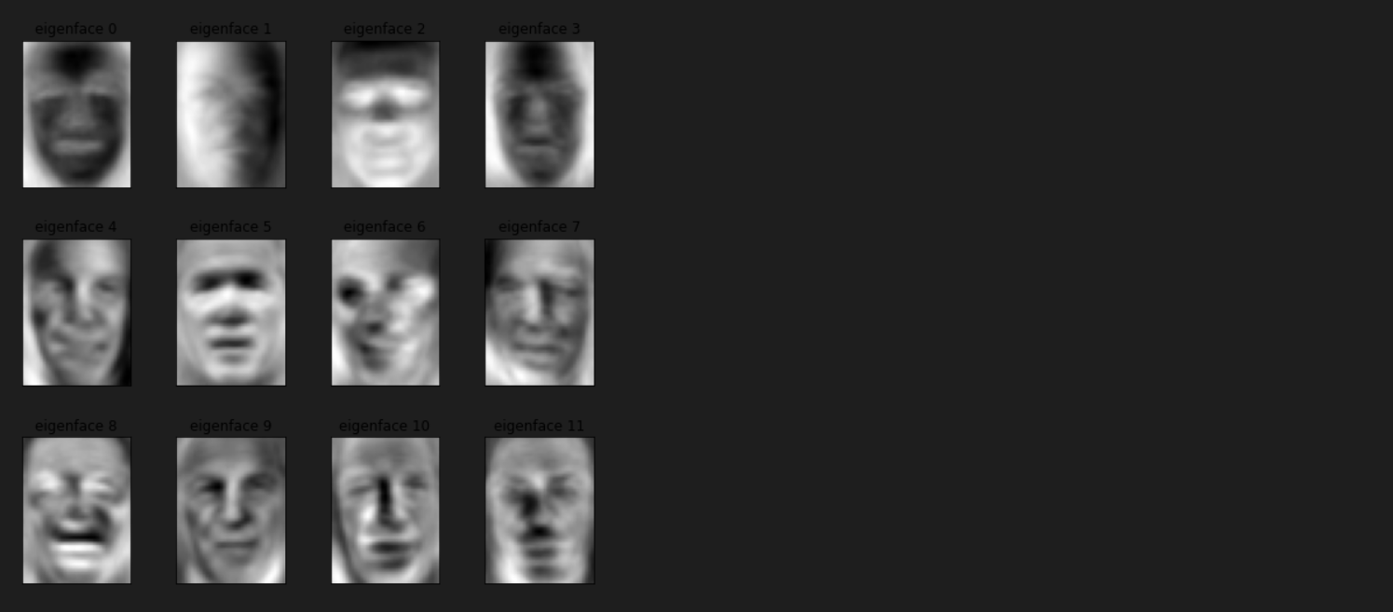

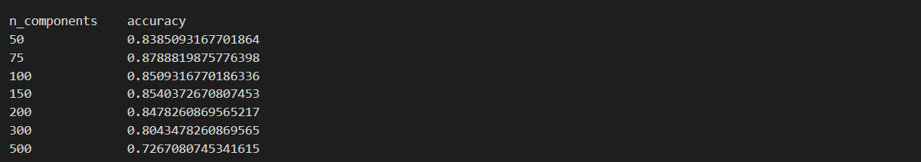

By gradually increasing the n_components the accuracy is decreasing, here you can see that at 75 the accuracy is high and at 500 the accuracy is low

**Table of results for PCA for different n_component value(classification report)**

n_components classification_report

50 precision recall f1-score support

Ariel Sharon 0.39 0.69 0.50 13

Colin Powell 0.78 0.83 0.81 60

Donald Rumsfeld 0.52 0.63 0.57 27

George W Bush 0.92 0.78 0.84 146

Gerhard Schroeder 0.68 0.84 0.75 25

Hugo Chavez 0.77 0.67 0.71 15

Tony Blair 0.74 0.69 0.71 36

accuracy 0.76 322

macro avg 0.68 0.73 0.70 322

weighted avg 0.79 0.76 0.77 322

75 precision recall f1-score support

Ariel Sharon 0.60 0.69 0.64 13

Colin Powell 0.83 0.83 0.83 60

Donald Rumsfeld 0.58 0.78 0.67 27

George W Bush 0.93 0.85 0.89 146

Gerhard Schroeder 0.68 0.84 0.75 25

Hugo Chavez 0.83 0.67 0.74 15

Tony Blair 0.80 0.78 0.79 36

accuracy 0.82 322

macro avg 0.75 0.78 0.76 322

weighted avg 0.83 0.82 0.82 322

100 precision recall f1-score support

Ariel Sharon 0.48 0.77 0.59 13

Colin Powell 0.82 0.85 0.84 60

Donald Rumsfeld 0.61 0.70 0.66 27

George W Bush 0.96 0.82 0.88 146

Gerhard Schroeder 0.68 0.84 0.75 25

Hugo Chavez 0.77 0.67 0.71 15

Tony Blair 0.70 0.78 0.74 36

accuracy 0.80 322

macro avg 0.72 0.77 0.74 322

weighted avg 0.83 0.80 0.81 322

150 precision recall f1-score support

Ariel Sharon 0.56 0.69 0.62 13

Colin Powell 0.77 0.88 0.82 60

Donald Rumsfeld 0.63 0.70 0.67 27

George W Bush 0.96 0.84 0.89 146

Gerhard Schroeder 0.69 0.80 0.74 25

Hugo Chavez 0.56 0.60 0.58 15

Tony Blair 0.83 0.81 0.82 36

accuracy 0.81 322

macro avg 0.72 0.76 0.73 322

weighted avg 0.83 0.81 0.82 322

200 precision recall f1-score support

Ariel Sharon 0.56 0.77 0.65 13

Colin Powell 0.82 0.85 0.84 60

Donald Rumsfeld 0.62 0.78 0.69 27

George W Bush 0.96 0.84 0.90 146

Gerhard Schroeder 0.70 0.92 0.79 25

Hugo Chavez 0.79 0.73 0.76 15

Tony Blair 0.88 0.81 0.84 36

accuracy 0.83 322

macro avg 0.76 0.81 0.78 322

weighted avg 0.85 0.83 0.84 322

300 precision recall f1-score support

Ariel Sharon 0.60 0.69 0.64 13

Colin Powell 0.78 0.83 0.81 60

Donald Rumsfeld 0.69 0.67 0.68 27

George W Bush 0.92 0.84 0.88 146

Gerhard Schroeder 0.68 0.76 0.72 25

Hugo Chavez 0.57 0.53 0.55 15

Tony Blair 0.66 0.75 0.70 36

accuracy 0.79 322

macro avg 0.70 0.73 0.71 322

weighted avg 0.80 0.79 0.79 322

500 precision recall f1-score support

Ariel Sharon 0.52 0.85 0.65 13

Colin Powell 0.64 0.85 0.73 60

Donald Rumsfeld 0.53 0.63 0.58 27

George W Bush 0.90 0.78 0.84 146

Gerhard Schroeder 0.67 0.56 0.61 25

Hugo Chavez 0.69 0.60 0.64 15

Tony Blair 0.82 0.64 0.72 36

accuracy 0.74 322

macro avg 0.68 0.70 0.68 322

weighted avg 0.77 0.74 0.75 322

----------------------------------------------------------------------------

**Table of results for PCA for different n_component value(Accuracy)**

n_components accuracy

50 0.7639751552795031

75 0.8167701863354038

100 0.8012422360248447

150 0.8105590062111802

200 0.8322981366459627

300 0.7888198757763976

500 0.7422360248447205

----------------------------------------------------------------------------

**ICA(Independent Component Analysis):** Independent Component Analysis helps to divide multivariate signals into subcomponents that are assumed to be independent of each other.

Classification for 50 components: accuracy is 76%

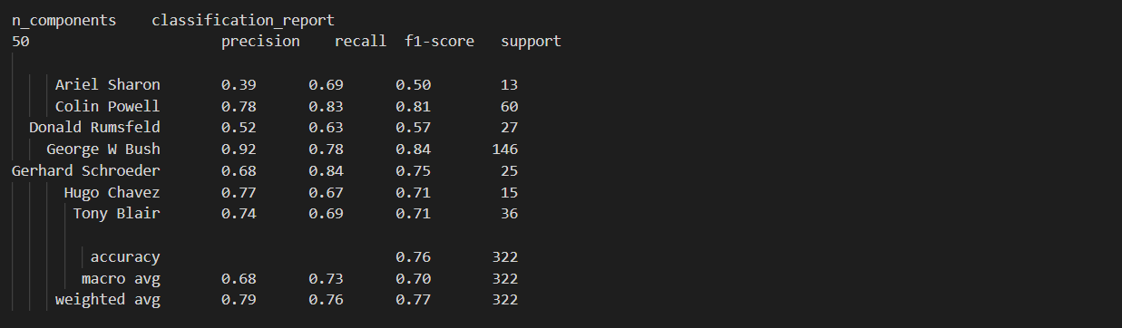

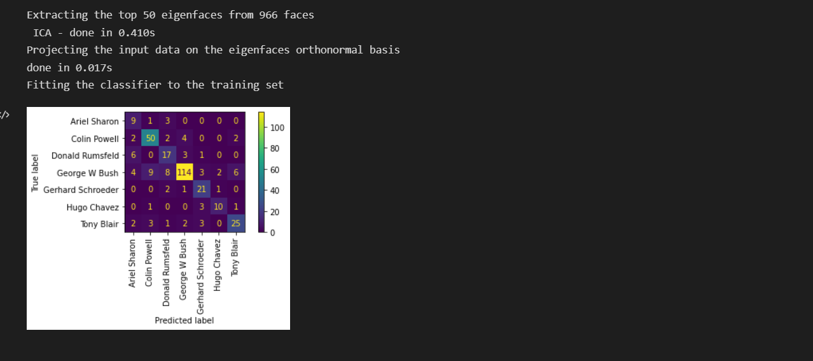

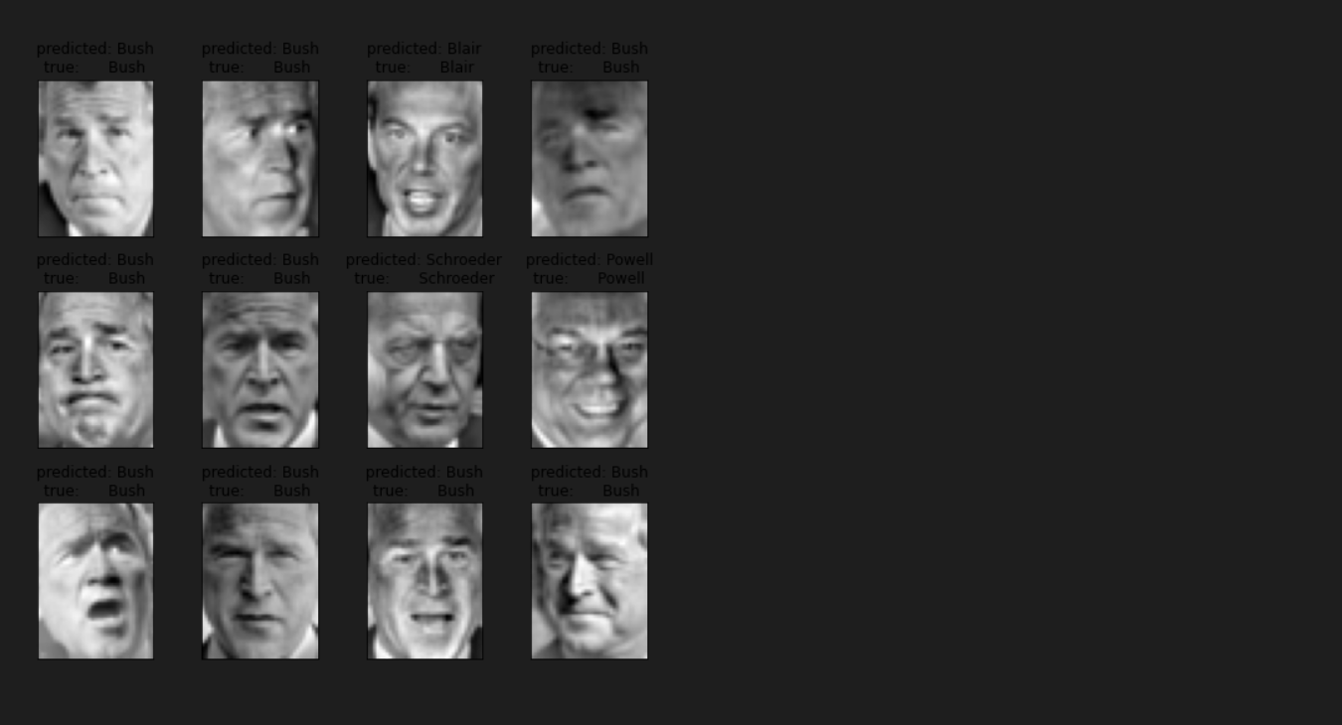

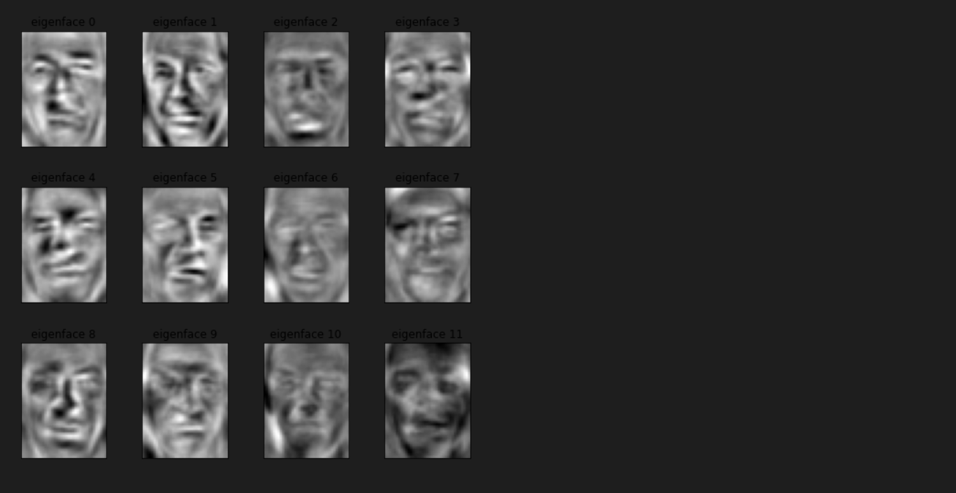

Classification for 75 components:accuracy is 82%

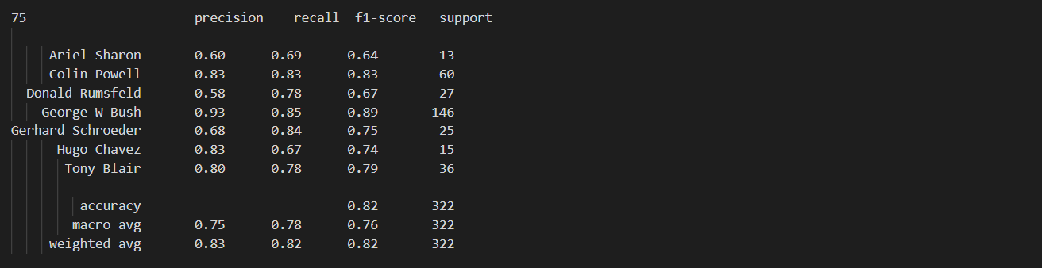

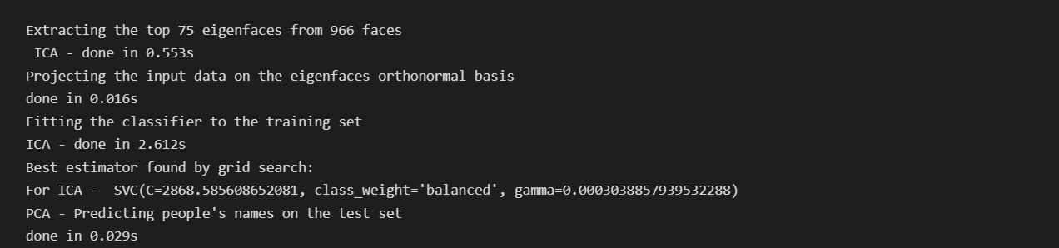

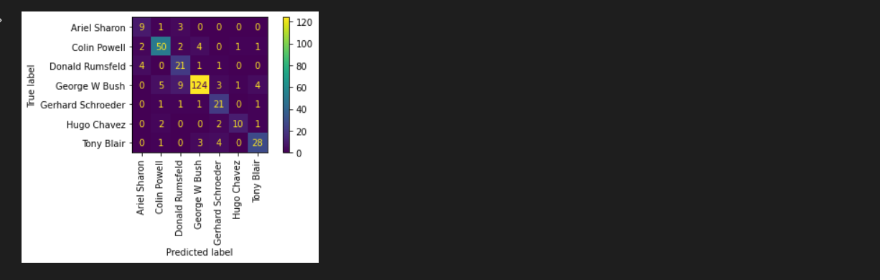

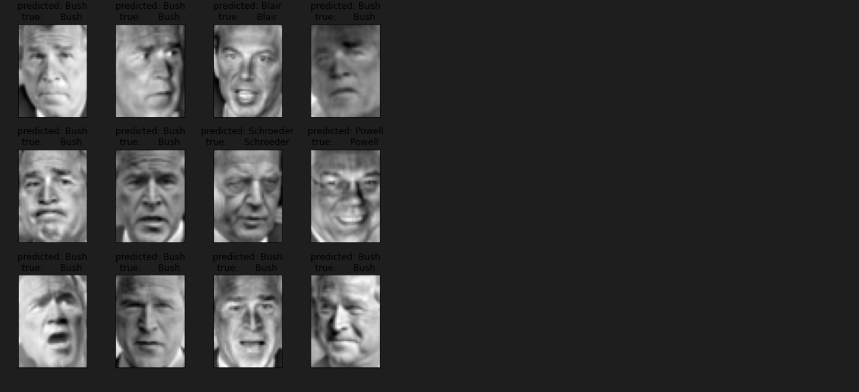

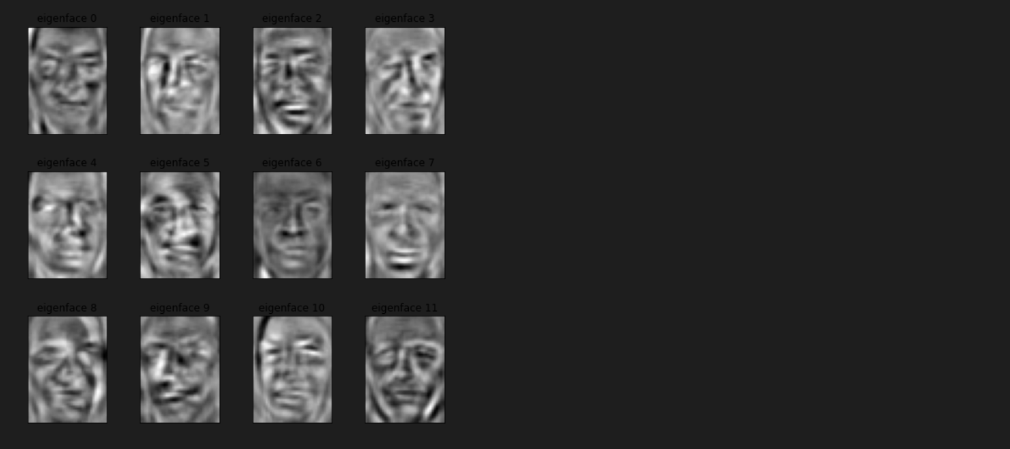

Classification for 100 components:accuracy is 80%

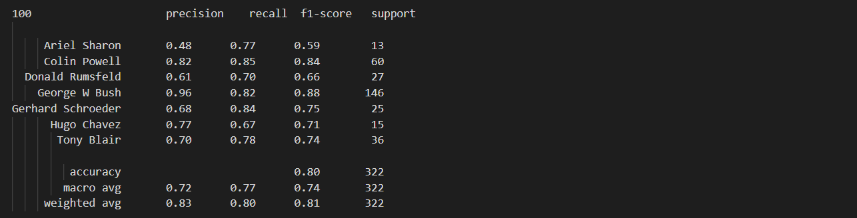

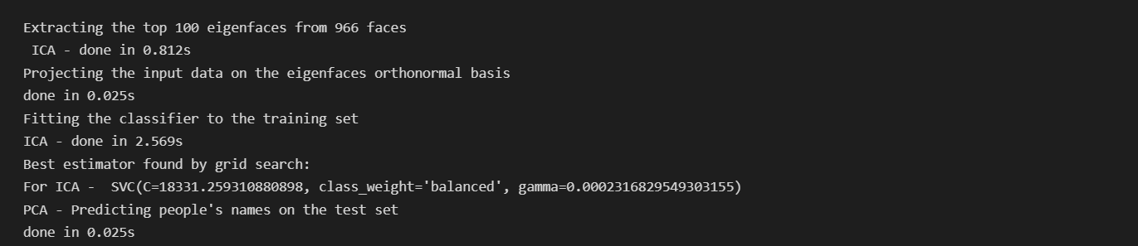

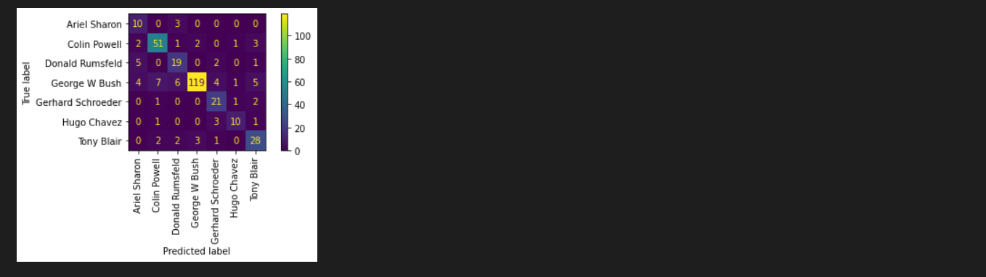

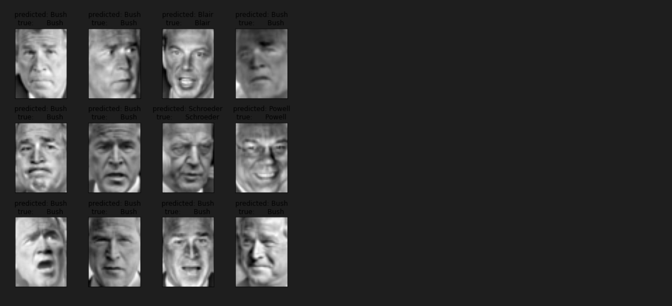

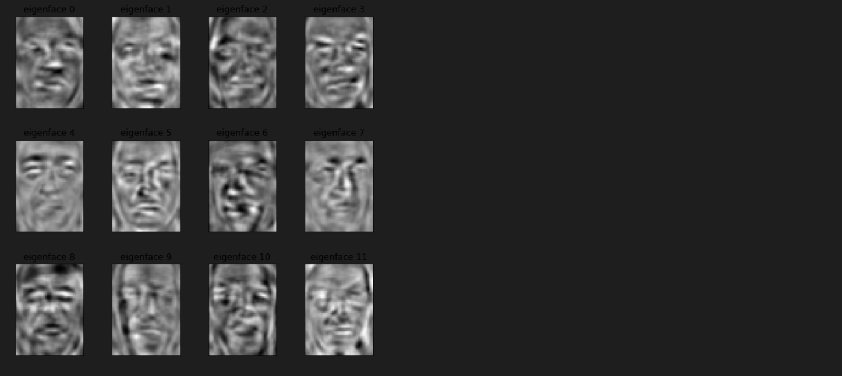

Classification for 150 components:accuracy is 81%

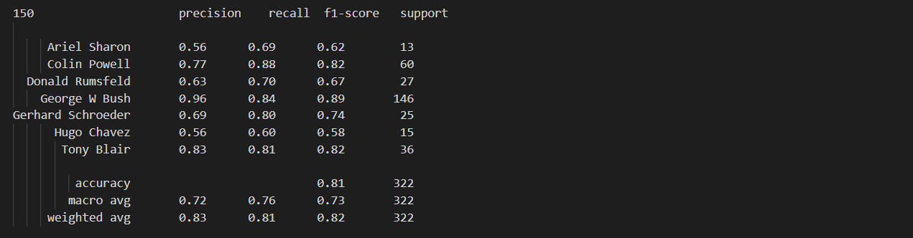

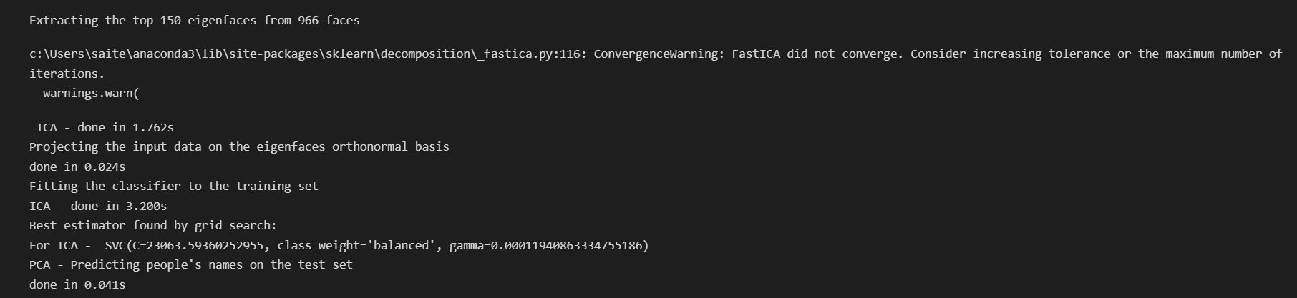

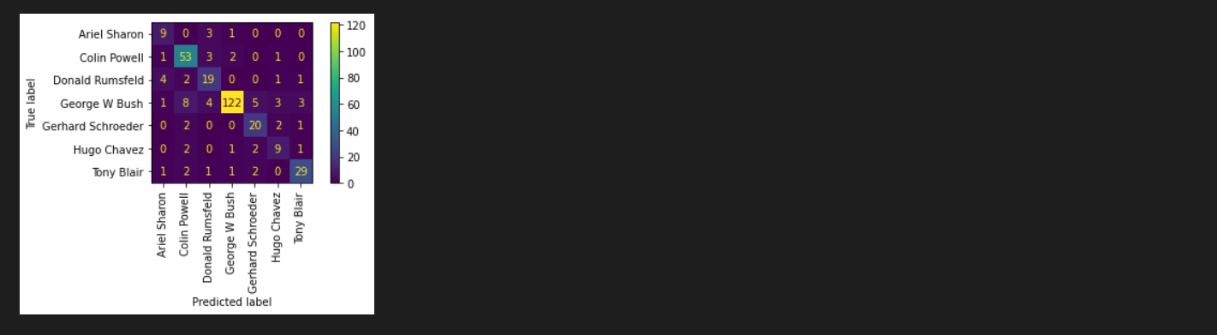

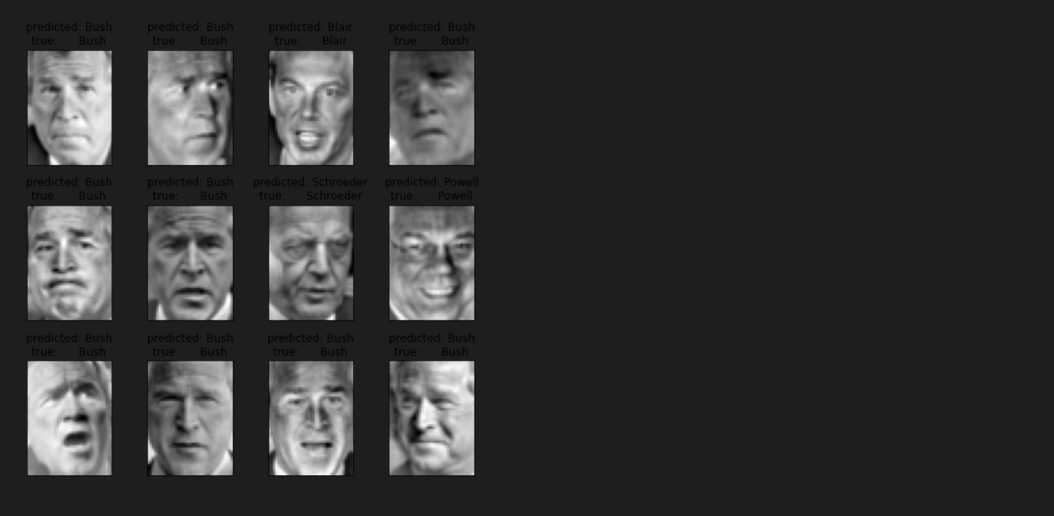

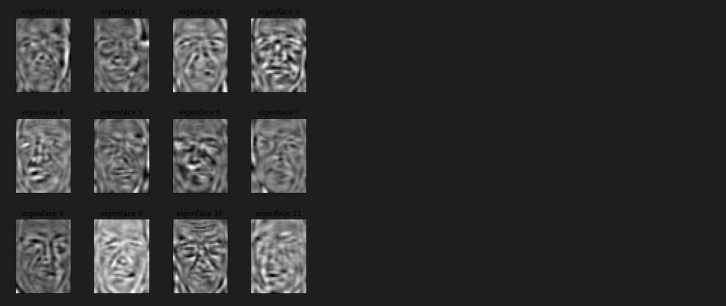

Classification for 200 components:accuracy is 83%

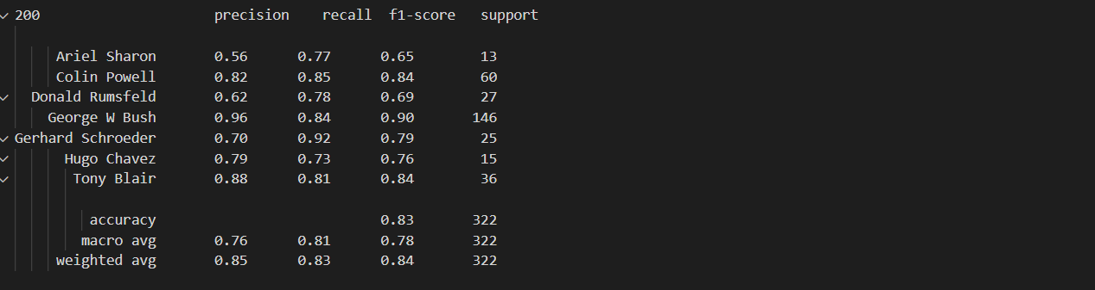

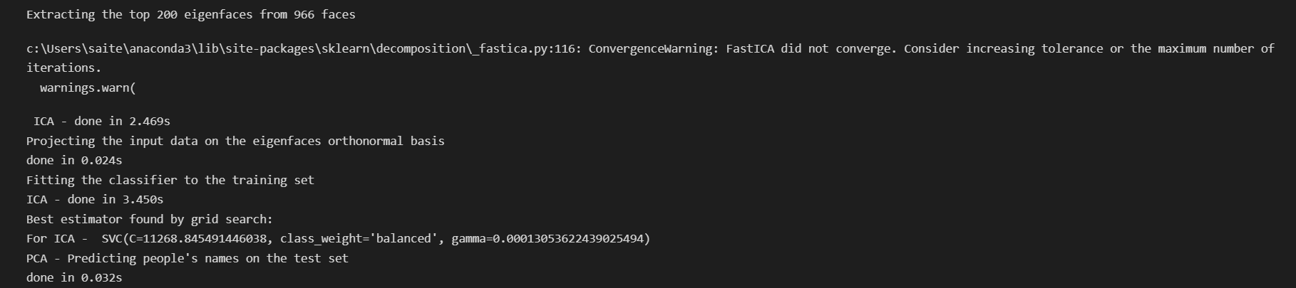

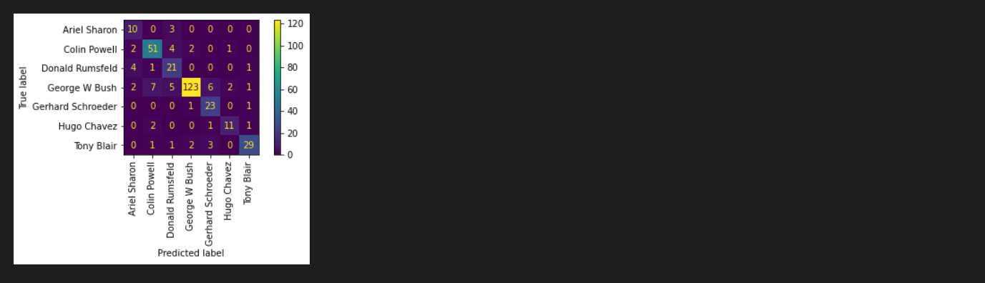

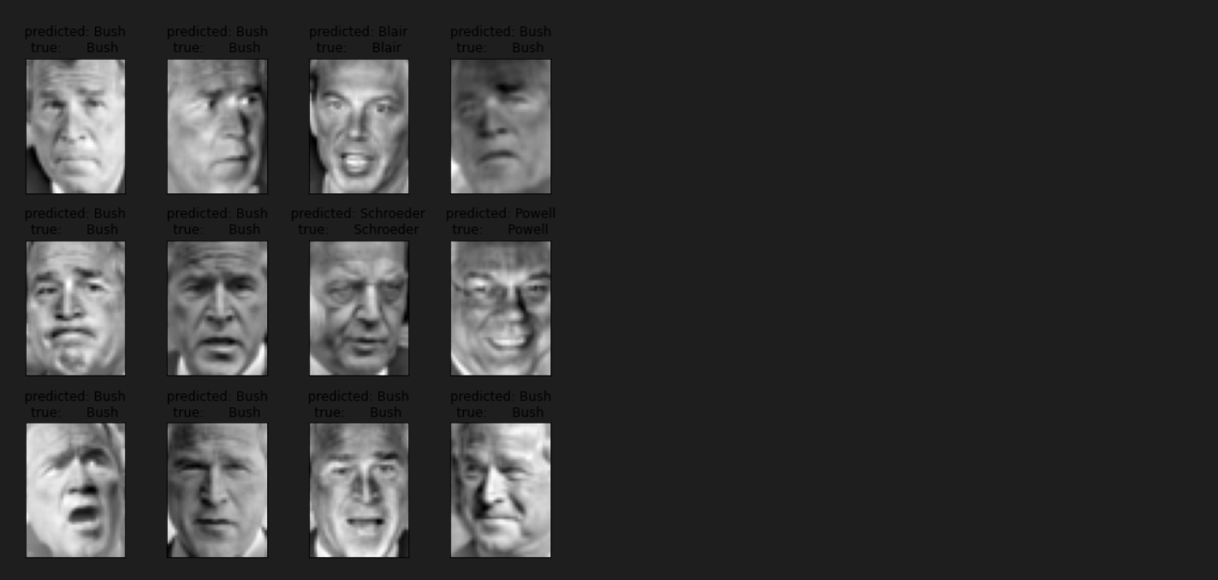

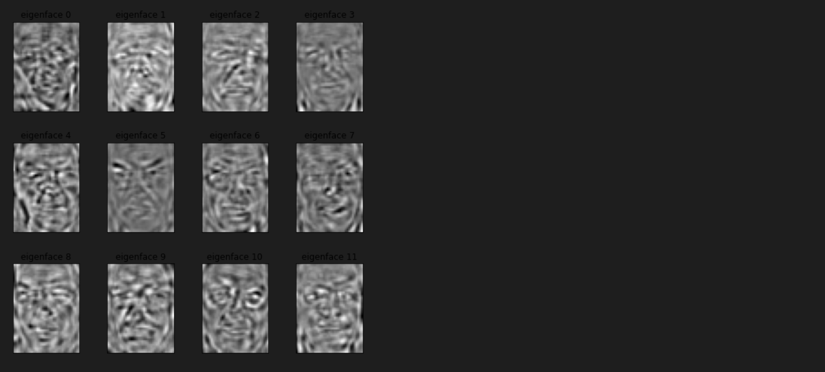

Classification for 300 components:accuracy is 79%

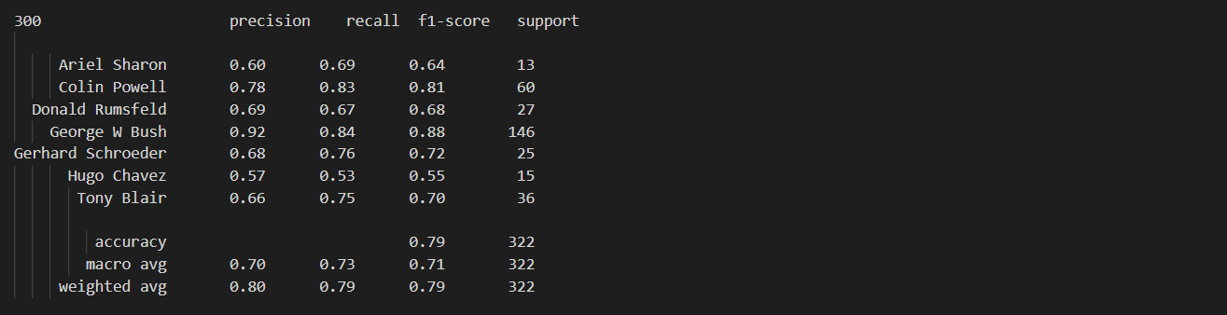

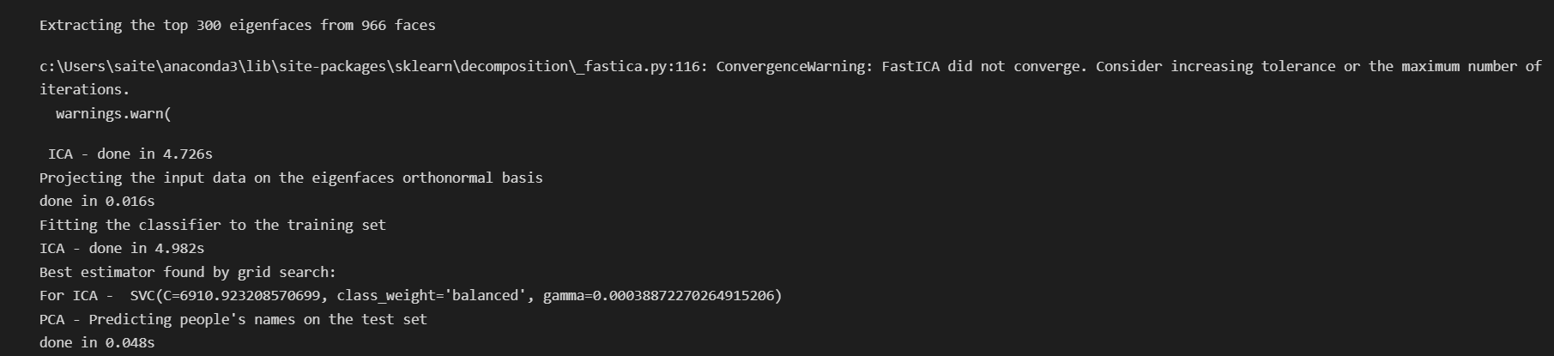

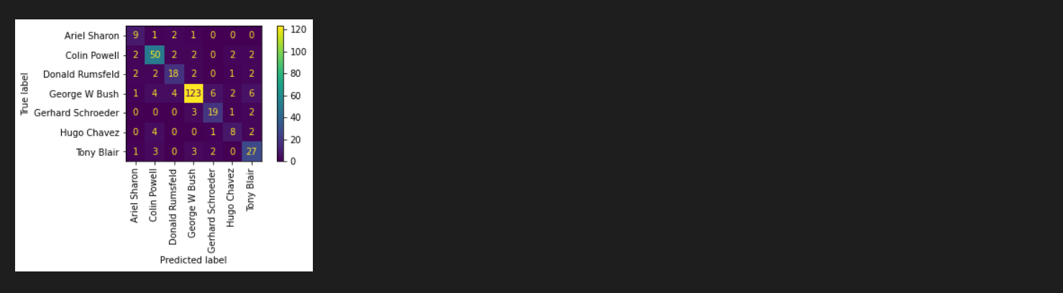

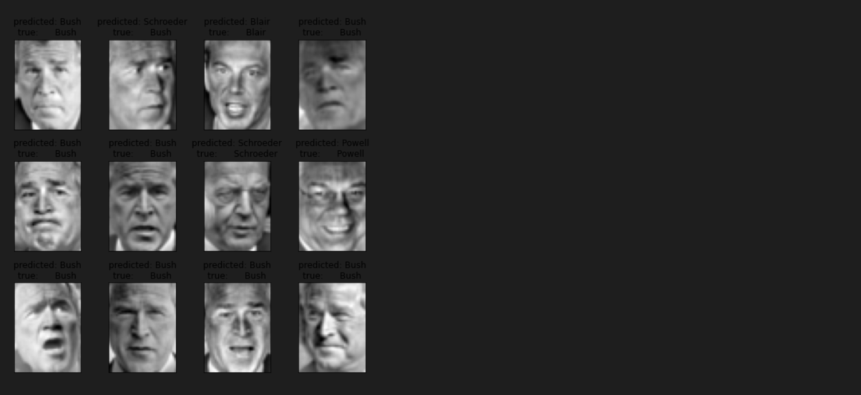

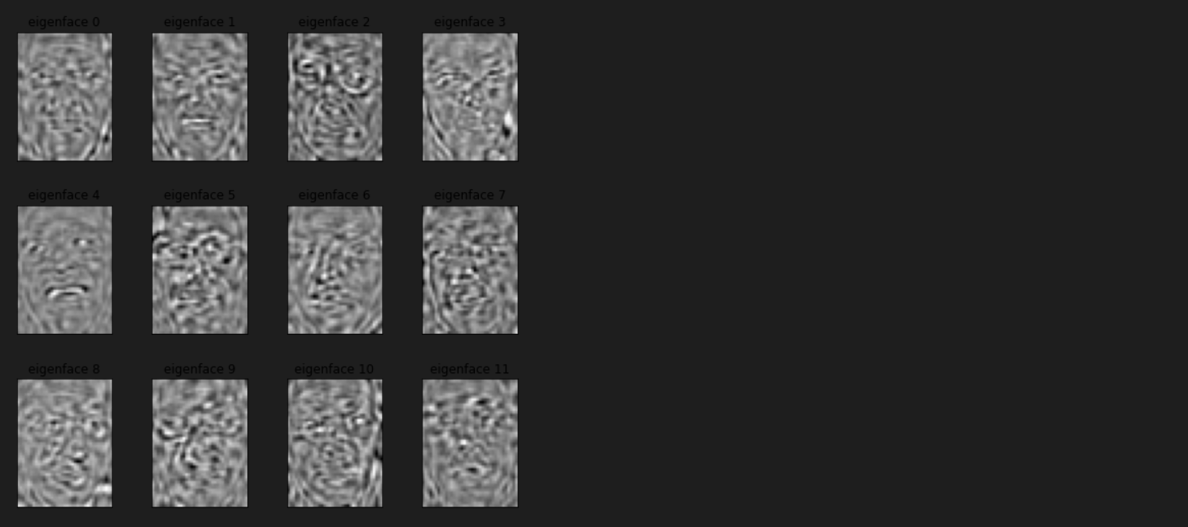

Classification for 500 components:accuracy is 74%

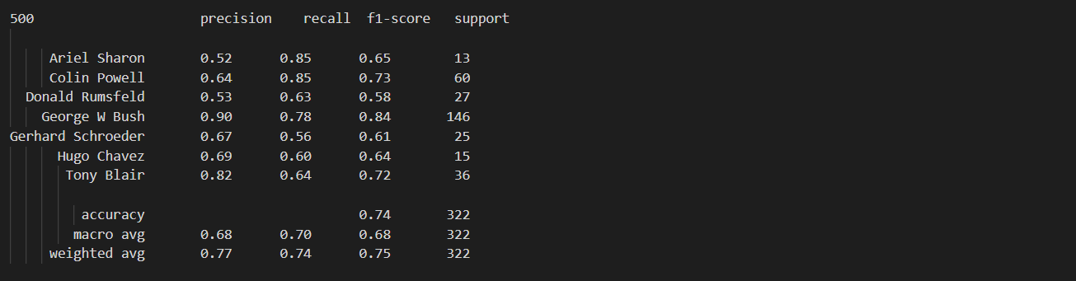

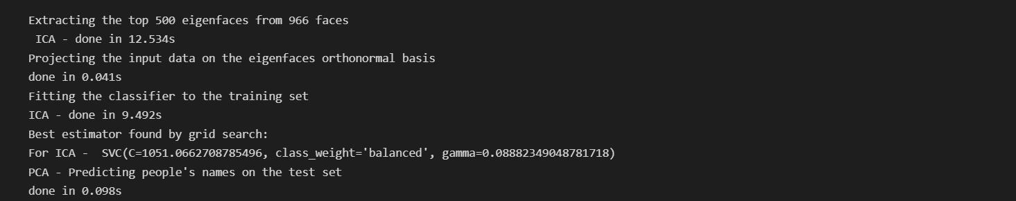

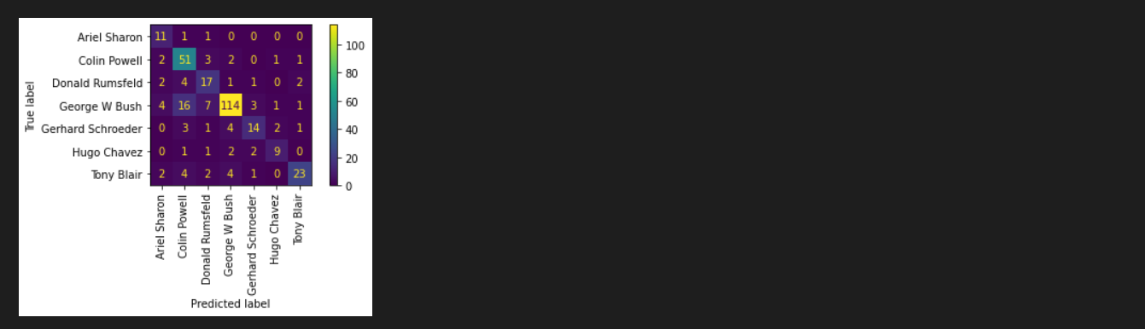

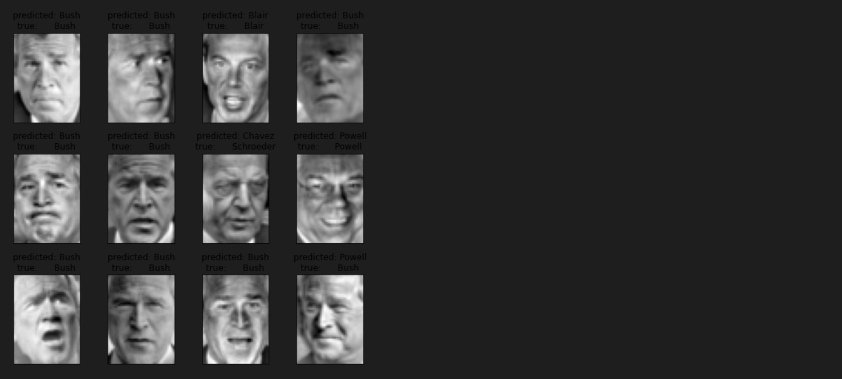

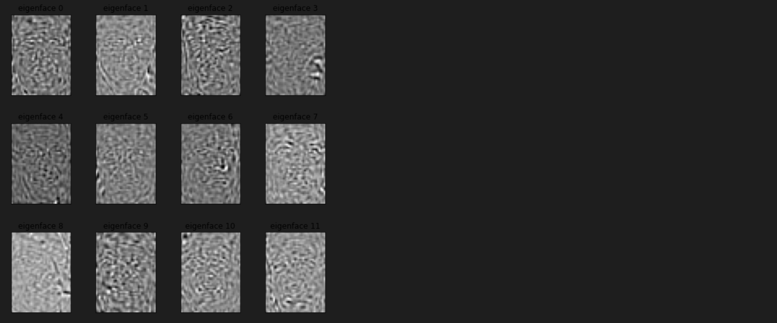

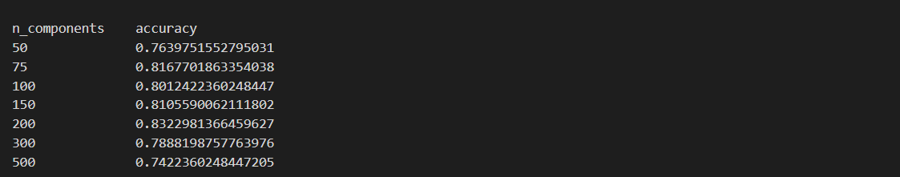

By the above accuracy, we can assume that by gradually increasing the n_components the accuracy of the,it is high at 200 and at 500 it is low

**Table of results for ICA for different n_component value(classification report)**

n_components classification_report

50 precision recall f1-score support

Ariel Sharon 0.39 0.69 0.50 13

Colin Powell 0.78 0.83 0.81 60

Donald Rumsfeld 0.52 0.63 0.57 27

George W Bush 0.92 0.78 0.84 146

Gerhard Schroeder 0.68 0.84 0.75 25

Hugo Chavez 0.77 0.67 0.71 15

Tony Blair 0.74 0.69 0.71 36

accuracy 0.76 322

macro avg 0.68 0.73 0.70 322

weighted avg 0.79 0.76 0.77 322

75 precision recall f1-score support

Ariel Sharon 0.60 0.69 0.64 13

Colin Powell 0.83 0.83 0.83 60

Donald Rumsfeld 0.58 0.78 0.67 27

George W Bush 0.93 0.85 0.89 146

Gerhard Schroeder 0.68 0.84 0.75 25

Hugo Chavez 0.83 0.67 0.74 15

Tony Blair 0.80 0.78 0.79 36

accuracy 0.82 322

macro avg 0.75 0.78 0.76 322

weighted avg 0.83 0.82 0.82 322

100 precision recall f1-score support

Ariel Sharon 0.48 0.77 0.59 13

Colin Powell 0.82 0.85 0.84 60

Donald Rumsfeld 0.61 0.70 0.66 27

George W Bush 0.96 0.82 0.88 146

Gerhard Schroeder 0.68 0.84 0.75 25

Hugo Chavez 0.77 0.67 0.71 15

Tony Blair 0.70 0.78 0.74 36

accuracy 0.80 322

macro avg 0.72 0.77 0.74 322

weighted avg 0.83 0.80 0.81 322

150 precision recall f1-score support

Ariel Sharon 0.56 0.69 0.62 13

Colin Powell 0.77 0.88 0.82 60

Donald Rumsfeld 0.63 0.70 0.67 27

George W Bush 0.96 0.84 0.89 146

Gerhard Schroeder 0.69 0.80 0.74 25

Hugo Chavez 0.56 0.60 0.58 15

Tony Blair 0.83 0.81 0.82 36

accuracy 0.81 322

macro avg 0.72 0.76 0.73 322

weighted avg 0.83 0.81 0.82 322

200 precision recall f1-score support

Ariel Sharon 0.56 0.77 0.65 13

Colin Powell 0.82 0.85 0.84 60

Donald Rumsfeld 0.62 0.78 0.69 27

George W Bush 0.96 0.84 0.90 146

Gerhard Schroeder 0.70 0.92 0.79 25

Hugo Chavez 0.79 0.73 0.76 15

Tony Blair 0.88 0.81 0.84 36

accuracy 0.83 322

macro avg 0.76 0.81 0.78 322

weighted avg 0.85 0.83 0.84 322

300 precision recall f1-score support

Ariel Sharon 0.60 0.69 0.64 13

Colin Powell 0.78 0.83 0.81 60

Donald Rumsfeld 0.69 0.67 0.68 27

George W Bush 0.92 0.84 0.88 146

Gerhard Schroeder 0.68 0.76 0.72 25

Hugo Chavez 0.57 0.53 0.55 15

Tony Blair 0.66 0.75 0.70 36

accuracy 0.79 322

macro avg 0.70 0.73 0.71 322

weighted avg 0.80 0.79 0.79 322

500 precision recall f1-score support

Ariel Sharon 0.52 0.85 0.65 13

Colin Powell 0.64 0.85 0.73 60

Donald Rumsfeld 0.53 0.63 0.58 27

George W Bush 0.90 0.78 0.84 146

Gerhard Schroeder 0.67 0.56 0.61 25

Hugo Chavez 0.69 0.60 0.64 15

Tony Blair 0.82 0.64 0.72 36

accuracy 0.74 322

macro avg 0.68 0.70 0.68 322

weighted avg 0.77 0.74 0.75 322

----------------------------------------------------------------------------

**Table of results for ICA for different n_component value(Accuracy)**

n_components accuracy

50 0.7639751552795031

75 0.8167701863354038

100 0.8012422360248447

150 0.8105590062111802

200 0.8322981366459627

300 0.7888198757763976

500 0.7422360248447205

----------------------------------------------------------------------------

**visualization:**

* Randomly generated true dependent values from random state 42
* Subplot 2 is for PCA components gives out scatter plot for Eigen face values
* Subplot 3 is for ICA components gives out scatter plot for Eigen face values

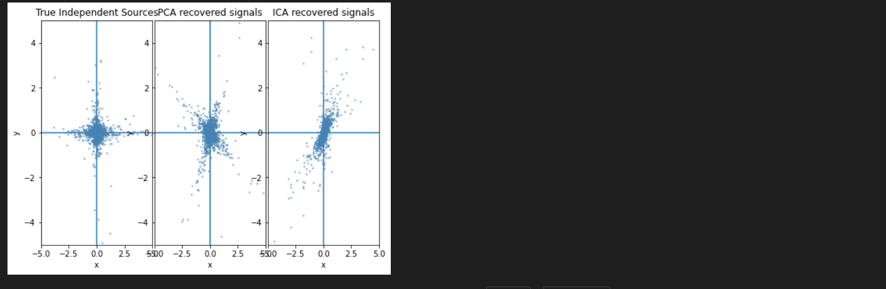

Both the PCA and ICA quiver line overlapped each other because we took the data in a small amount of dataset

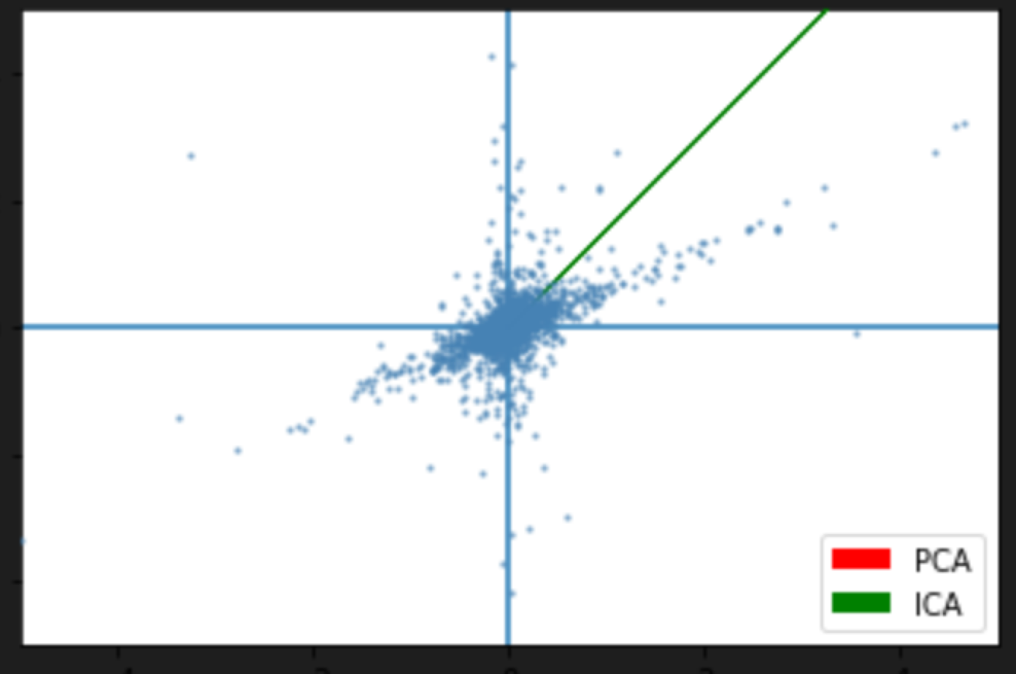

**Discussion:**

PCA :

High-dimensional data can be made simpler through the use of principal component analysis (PCA), while still preserving trends and patterns.

We use StandardScaler(standardization method) to prevent features with wider ranges.

In principal component analysis(PCA) are represented by the eigenvectors which are stored in the attribute components.

The variance in the eigenvector's direction is represented by the eigenvalues.

We calculate eigenvalues to understand the direction of spread of data

Choosing components range from 50 to 500.

When components value is 50 a cumulative variance is low, when components value is 75 it will account for 95% of the variance and also this helps in mitigating the overfitting. When components value is more than 150 the cumulative variance is relatively low.

ICA :

A machine learning method called Distinct Component Analysis (ICA) is used to distinguish independent sources from a mixed input. In contrast to principal component analysis, which emphasizes maximizing data point variance, independent component analysis emphasizes independence, or independent components.

We use StandardScaler(standardization method) to prevent features with wider ranges.

We calculated the eigenvalues of the covariance matrix so that we get the main component of the data.

Choosing components range from 50 to 500.

If the component is less than 150 it will give the less number of independent signals. We selected 200 for more independent signal and reduce overfitting. When components is more than 200 accuracy is very low